Lesson 6: Anatomy of the Alimentary Tract
Exercise 1. Learn the new words:
1. |  | alimentary tract | [ælɪˌment(ə)rɪ trækt] | пищеварительный тракт
2. |  | length | [leŋθ] | длина
3. |  | pancreas | ['pæŋkrɪəs] | поджелудочная железа
4. |  | salivary glands | ['sælɪvərɪ glænd] | слюнные железы
5. |  | portion | [’pɔ:rʃən] | часть
6. |  | tube | [tju:b] | трубка
7. |  | duodenum | [dju:ou'di:nəm] | двенадцатиперстная кишка
8. |  | jejunum | [dʒiːˈdʒuːnəm] | тощая кишка
9. |  | ileum | ['ɪlɪəm] | подвздошная кишка
10 |  | caecum | ['si:kəm] | слепая кишка
11 |  | colon | ['koulən] | ободочная (толстая) кишка
12 |  | rectum | ['rektəm] | прямая кишка
13 |  | decomposition | [dikompəzishˈən] | разложение
14 |  | oral cavity | [ɔ: rl ] | ротовая полость
15 |  | abdomen cavity | [`æbdəmn] | брюшная полость
16 |  | sac | [sak] | мешок
17 |  | bile | [bail] | желчь
18 |  | store | [st ɔ:] | запасать, хранить
19 |  | release | [ri`li:s] | выпускать, освобождать
20 |  | anus | [`einəs] | задний проход
21 |  | gland | [glænd] | железа
22 |  | tongue | [ tʌŋ] | язык
23 |  | palate (soft, hard) | [ `pælit] | небо (мягкое, твердое)
24 | portion |  | [`p ɔ:ʃn] | часть, отдел, доля
25 | through |  | [θru:] | через, сквозь, по, с

Exercise 2. Read the following word-combinations and translate them.

А) canal: alimentary canal, musculomembraneous canal, nasal canal,
cavity: oral cavity, abdominal cavity, nasal cavity, thoracic cavity
gland: salivary gland, endocrine gland, urethral glands
tube: thin-wall muscular tube, inner-tube, test-tube
palate: hard palate, soft palate

В) рот, желудок, тонкий кишечник, толстый кишечник, желчный пузырь, глотка, пищевод, двенадцатиперстная кишка, прямая кишка.

Exercise 3. Translate the following word combinations into Russian:
To extend from the oral cavity to the anus, the first division, to pass through the pharynx to the esophagus, the upper part of the abdomen, to be composed of, a thin-walled muscular tube, to absorb water, the largest gland in the human body, a major role in metabolism, a number of functions in the body, decomposition of red blood cells, a hollow sac, a long thin gland.

Exercise 4. Choose the words concerning to The parts of the Alimentary Tract. Write them down.
Ileum, heart, vessel, anus, jejunum, artery, duodenum, tongue, vein, pharynx, stomach, capillary, esophagus, intestine, aorta, atria, rectum, oral cavity, salivary glands, mouth, chamber, caecum, colon, teeth, ventricle.
Exercise 5. Read and translate the text:
The Anatomy of Alimentary Tract
The alimentary tract is a musculomembraneous (мышечно-перепончатый) canal about 8½ metres in length. It extends from the oral cavity to the anus. It consists of the mouth, pharynx, esophagus, stomach, small intestine, and large intestine. The liver with gallbladder and pancreas are the large glands of the alimentary tract.
The first division of the alimentary tract is formed by the mouth. Important structures of the mouth are the teeth and the tongue, which is the organ of taste. The soft and hard palates and the salivary glands are also in the oral cavity.
From the mouth food passes through the pharynx to the esophagus and then to the stomach.
The stomach is a muscular, hollow, dilated portion of the alimentary canal. It is in the upper part of the abdomen under the diaphragm. It measures about 21 -25 cm in length, 8-9 cm in its greatest diameter. It has a capacity of from 2.14 to 4.28 1 (litres).
The small intestine is a thin-walled muscular tube about 6.5 metres long. It is located in the middle portion of the abdominal cavity. The small intestine is composed of the duodenum, jejunum and ileum.
The large intestine is the last part of the alimentary tract. Its function is to absorb water from the remaining indigestible food matter, and then to pass useless waste material from the body. It is about 1.5 meters long. It is divided into caecum, colon and rectum.
The liver is the largest gland in the human body. It is in the right upper part of the abdominal cavity under the diaphragm. The weight of the liver is 1,500 g. This organ plays a major role in metabolism and has a number of functions in the body, including glycogen storage, decomposition of red blood cells, plasma protein synthesis, hormone production, and detoxification.
The gallbladder is a hollow sac lying on the lower surface of the liver, where bile is stored, before it is released into the small intestine.
The pancreas is a long thin gland lying behind the stomach.

Exercise 6. Answer the questions to the text:
1. What is the alimentary tract?
2. What does the alimentary tract consist of?
3. What is the 1st division of the alimentary tract formed by?
4. What is the stomach?
5. What is the small intestine?
6. What is the function of the large intestine?
7. What largest gland in the human body do you know?
8. What is the function of the gallbladder?

Exercise 7. Translate the following word combinations into English:
пищеварительный тракт; он простирается от полости рта до заднего прохода, под диафрагмой, он имеет емкость; тонкостенная мышечная трубка; в средней части брюшной полости; 1,5 метров в длину; он разделен на; самая большая железа в организме; играет важную роль в; имеет ряд функций в организме; полый мешок; производство гормонов и детоксикация ; длинная тонкая железа, лежащая за желудком.

Exercise 8. Match the terms with their definitions:

1. alimentary tract  2. stomach  3. pharynx  4. small intestine  5. large intestine  6.esophagus | a) the passage between the pharynx and the stomach  b) the passage to the stomach and lungs; in the front part of the neck below the chin and above the collarbone  c) beginning with the cecum and ending with the rectum; includes the caecum and the colon and the rectum; extracts moisture from food residues which are later excreted as feces  d) the tubular passage extending from the mouth to the anus, through which food is passed and digested  e) the longest part of the alimentary canal; where digestion is completed  f) an enlarged and muscular saclike organ of the alimentary canal; the principal organ of digestion

Exercise 9. Say what organ is spoken about:
А). This organ is the largest gland in the human body. It is in the upper part of the abdominal cavity under the diaphragm in the right side of the abdomen. Its upper surface is convex. This organ consists of small lobules connected together by connective tissue, different vessels and nerves.
В). This organ is pyriform (грушевидный) in shape. It is a dilated portion of the alimentary canal. It is in the upper part of the abdomen under the diaphragm. The liver is above this organ, and the colon is below it. The pancreas is behind this organ.
С). It is the beginning of the alimentary tract and the digestion starts here when taking the first bite of food. Chewing breaks the food into pieces that are more easily digested, while saliva mixes with food to begin the process of breaking it down into a form your body can absorb and use.
D). This organ is the portion of the alimentary tract that is located between the stomach and rectum. In the human being it is divided in to two parts. Its function is to digest food and to enable the nutrients released from that food to enter into the bloodstream.

Exercise 10. Open the brackets using the verb in the appropriate form:
1. The mechanical digestion of the food (to start) by the action of mastication and the wetting contact of saliva.
2. The esophagus (to line) with smooth muscle, which forces the food down the pipe to the stomach.
3. When food is swallowed, the stomach (to produce) hydrochloric acid.
4. The shape of the stomach (to change) when it delates and its borders greatly extend.
5. The liver (to play) a major role in metabolism and (to have) a number of functions in the body.
6. Discharged from the liver bile (to store) in the gallbladder.
7. 95% of absorption of nutrients (to occur) in the small intestine.
8. Waste material (to eliminate) from the rectum during defecation.

Exercise 11. Read the text once again and write in series all parts of the Alimentary Tract.
The Alimentary Tract
a musculomembraneous canal about 8.5 meters in length

- mouth  - the teeth  - the tongue (the organ of taste)  - the soft and hard palates  - the salivary glands | the oral cavity
- the pharynx
- the esophagus
- -the stomach (21-25 cm in length, a capacity of 2.14 – 4.281 )
- duodenum  - jejunum  - - ileum | the small intestine  (6.5 m long)
- caecum  - colon  - rectum | the large intestine  (1.5 m long)
the anus

The largest glands in the human body
- the liver (1.5 kg)
- the gallbladder
- the pancreas

Exercise 11. Speak about The Alimentary Tract using as a plan:
A
1. Пищеварительная система представляет собой трубку, каждый участок которой выполняет определенную роль в процессе переваривания и всасывания пищи.
2. Процесс пищеварения начинается в ротовой полости, где пища пережевывается и смачивается слюной.
3. Затем по пищеводу пища попадает в желудок, где происходит её дальнейшее переваривание.
4. После расщепления начинается процесс всасывания, который протекает в основном в тонком и толстом отделах кишечного тракта.
5. Непереваренные остатки пищи, проходя по прямой кишке, выводятся из организма через анальное отверстие.
B
1. Пищеварительный тракт - это мышечно-перепончатый канал длиной около 8.5 метра.
2. Он простирается от полости рта до заднего прохода.
3. Он состоит из рта, глотки, пищевода, желудка, тонкой кишки и толстой кишки.
4. Печень с желчным пузырем и поджелудочной железой представляет собой большие железы пищеварительного тракта.
5. Процесс пищеварения начинается в ротовой полости.
6. Затем пища попадает в желудок по пищеводу.
7. Из желудка пища попадает в кишечник.
8. Тонкий и толстый кишечник имеют несколько отделов.
9. Каждый отдел выполняет (perform) конкретные функции (specific functions) в процессе пищеварения.
10. Непереваренные остатки пищи, проходя по прямой кишке, выводятся из организма через анальное отверстие.

The Alimentary Tract

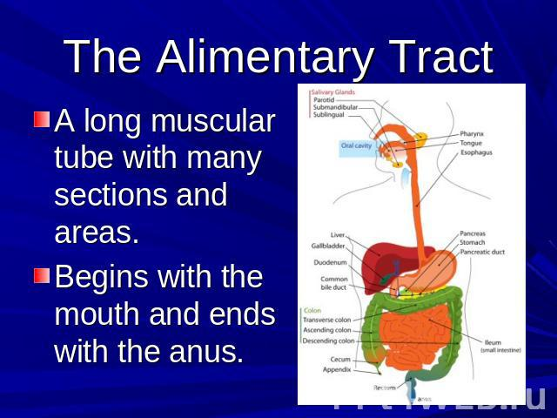

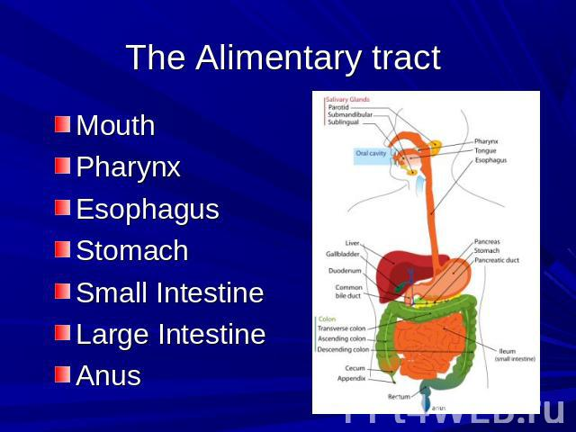

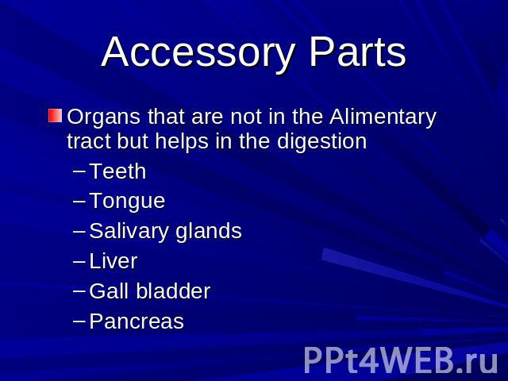
Control Tests. Digestive System
1. Where does food get in at first?
A. Esophagus
B. Oral cavity
C. The small intestine
D. The large intestine
E. Stomach
2. What is the organ of taste?
A. Mouth
B. Nose
C. Skin
D. Tongue
E. Eye
3. The roof in the mouth is …
A. palace
B. house
C. palate
D. ceiling
E. tongue
4. What is the role of teeth in the oral cavity?
A. To chew food
B. To drink water
C. To speak English
D. To keep food in the mouth
E. To do exercises
5. Where does food go from the oral cavity?
A. Esophagus
B. Stomach
C. Duodenum
D. Pharynx
E. Larynx
6. What the most important part of the digestive tract?
A. Stomach
B. Large intestine
C. Small intestine
D. Pancreas
E. Liver
7. What organ also takes part in digestion?
A. Kidney
B. Heart
C. Brain
D. Liver
E. Lung
8. Through it fecal masses go out the body.
A. Stomach
B. Lungs
C. Rectum
D. Anus
E. Liver
9. Through it food gets into the stomach.
A. Liver
B. Esophagus
C. Duodenum
D. Rectum
E. Pancreas
10. What is a part of large intestine?
A. Duodenum
B. Liver
C. Kidney
D. Colon
E. Bladder
11. It doesn't belong to the digestive system.
A. Heart
B. Gall bladder
C. Liver
D. Pancreas
E. Stomach
12. Where does food go after the duodenum?
A. Into the stomach
B. Into the small intestine
C. Into the blood vessels
D. Into the rectum
E. Into the pharynx
13. Where are fecal masses formed?
A. In the kidneys
B. In the bladder
C. In the appendix
D. In the rectum
E. In the large intestine
14. What doctor treats diseases of the digestive system?
A. Urologist
B. Neurologist
C. Stomatologist
D. Gastroenterologist
E. Cardiologist
15. If you want to eat, you are ...
A. hungry
B. sad
C. thirsty
D. happy
E. sick
16. The largest gland which secretes bile is ...
A. Tonsil
B. Pancreas
C. Thyroid
D. Liver
E. Gall bladder
17. Where is the stomach situated?
A. In the thoracic cavity
B. In the head
C. On the left side
D. On the right side
E. In the abdominal cavity

