Занятие 5: « Внутренние органы человека», «Системы органов»
(Inner Organs. Body Systems)

1.Выпишите в тетрадь и выучите слова по теме «Внутренние органы» (стр. 25-26. учебник Козыревой).

2. Послушайте песню:
https://www.songsforteaching.com/intellitunes/mybody.htm

Прочитайте слова этой детской песни и напишите, какую функцию выполняют разные органы.

My Body
My body is working
Day and night.
Working, working, all the time.
My body is working
Day and night,
All my organs keep my just right.
My brain controls everything,
Everything my body does.
My lungs are breathing in the air
Putting oxygen in my blood.
My heart is pumping blood
All around
My stomach's digesting
The food I've swallowed down.
My two intestines keep digesting
One is small and one is large.
My liver cleans blood and fights infection,
So many functions it's in charge.
Two kidneys clean my blood
Of harmful waste.
So many organs working
Keep me great!
My body is working
Day and night.
Working, working, all the time.
My body is working
Day and night,
All my organs keep my just right.
That's right!
From: My Body: Internal Organs
Song Lyrics and Sound Clip
by Ron Brown
1. My brain …
2. My lungs …
3. My heart …
4. My stomach …
5. My two intestines …
6. My two kidneys …

3. Посмотрите на картинку, закройте слова и попытайтесь назвать все внутренние органы человека. Показываем и называем, показываем и называем …

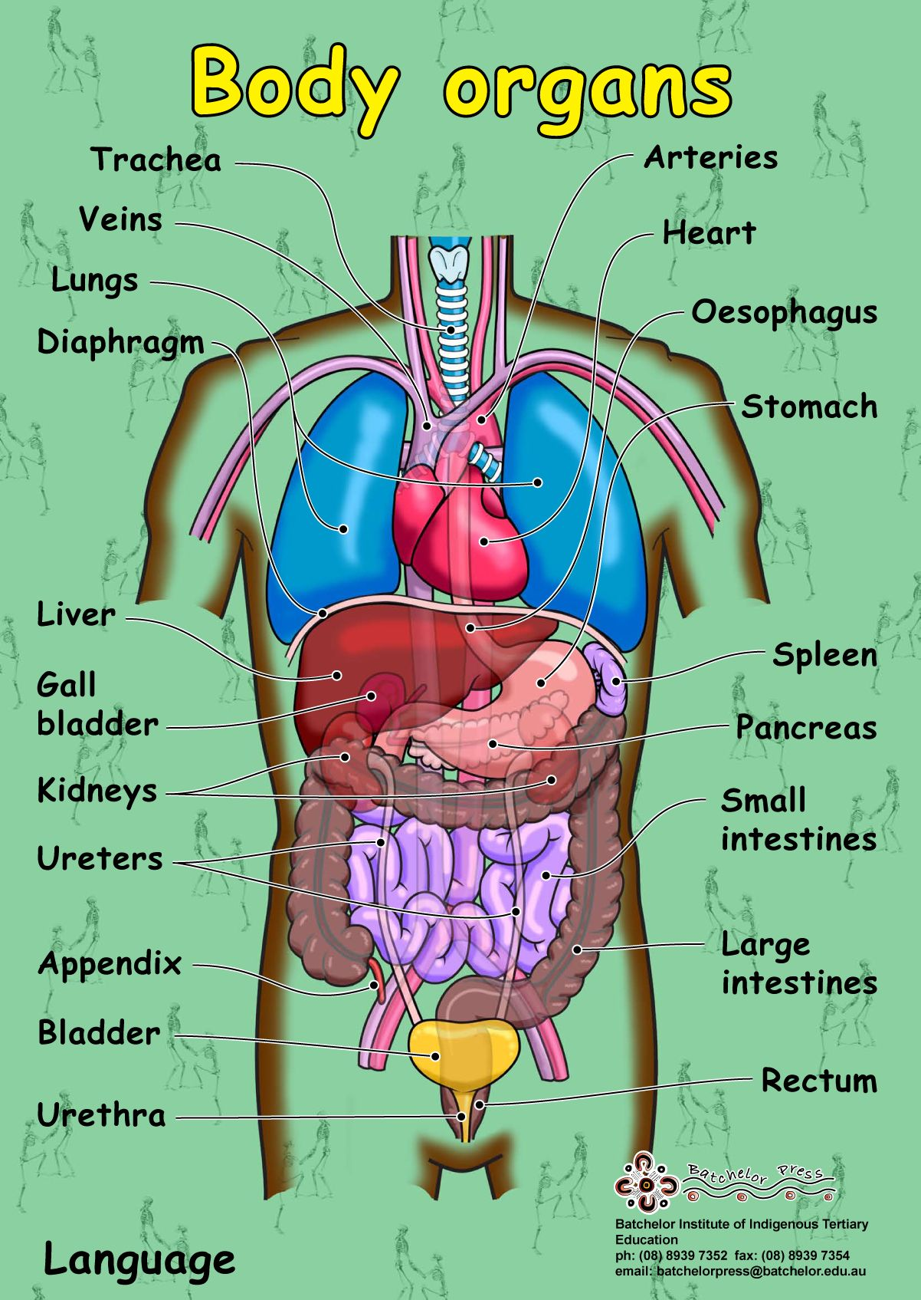

4. Прочтите текст, переведите и заполните таблицу, данную после текста.
Internal Organs
All internal organs are situated in the chest and abdomen. The chest is separated from the abdomen by the diaphragm. The principal organs of the chest are the gullet, the heart and the lungs. The gullet connects the pharynx and the stomach.
There are two lungs - one in each half of the chest. They differ in size. The right lung is larger than the left one. There is the heart between the lungs behind the breastbone. The heart pumps the blood to the whole body.
The lower part of the trunk is the abdominal cavity. The principal organs here are the stomach, the liver, two kidneys, the gallbladder, the pancreas, the spleen, the small and large intestines, the bladder and internal sex glands.
There is the liver with the gallbladder in the right upper abdominal part. The liver is the largest and heaviest organ in the body. It works over all the products of digestion. The liver destroys poisons and bacteria which get into the blood. There is the stomach, the pancreas and the spleen in the left upper part of the abdominal cavity. Behind them there are the right and left kidneys at the back.
The small and large intestines occupy the entire lower abdomen. Here is also the bladder and sex glands.
Each internal organ of the body plays a specific role in the organism.

Chest: the gullet
…
…

Abdominen: the stomach
….
….
….
…..
…..
….
…..
…..

5. Прочтите текст “Systems of the Body” заполните таблицу:

Systems | Organs
1.
2.
3.
4.
5.
6.
7.
8.

Systems of the Body
There are several main systems of the body: the skeletal, the muscular, the nervous, the digestive, the respiratory, the urinary, the endocrine and the reproductive systems.
The skeletal system consists of the bones of the body and ligaments and cartilages, which join them. The chief function of the skeletal system is structural.
The muscular system consists of the skeletal muscles and their associated structures. The main function of this system is to move us about.
The nervous system consists of the brain and spinal cord, nerves, ganglia and receptors. It is a complex information system with all the necessary means for receiving, processing and communicating information.
The circulatory system consists of the heart and blood vessels and the blood, which is pumped through the blood vessels by the heart. Its function is mainly that of transportation system: the nutrients, oxygen, special substances which are required by cells are carried by the blood stream; and the cellular wastes and sometimes other materials produced by the cells are carried away by the blood stream.
The digestive system consists of the alimentary canal and a number of associated glands.
The respiratory system consists of the lungs, the air passages leading to them and associated structures. Its main function is to convey oxygen to the lungs, where it can enter the blood stream and to remove carbon dioxide, which escapes from the blood into the lung spaces.
The urinary system consists of the kidneys which produce urine by removing nitrogenous and other wastes from the blood: the two ureters, which convey the urine away from the kidneys; the urinary bladder, where the urine is stored until it is discharged; and the urethra through which the urine is discharged.
The endocrine system consists of a number of glands throughout the body, which produce regulatory substances called hormones. The endocrine system serves to regulate a large number of activities.
Notes:
1. to move us about – осуществлять наше движение
2. for receiving, processing and communicating information – для
получения обработки и передачи информации
3. Which are required by cells – которые необходимы клеткам
4. by removing nitrogenous and other wastes – путем выведения
азотосодержащих и других продуктов отхода
5. where urine is stored – где накапливается моча

6. Answer the questions:
1. What are the main systems of the body?
2. What are the functions of the skeletal and muscular system?
3. What does the nervous system consist of?
4. What does the circulatory system include?
5. What does the digestive system consist of?
6. What does the respiratory system include?
7. What does the urinary system consist of?
8. What does the endocrine system include?
9. What is the most important body system? Why do you think so?

7. Заучите названия всех систем тела человека!
8. Перескажите текст “Systems of the Body”, используя вопросы упр. 6 и таблицу.

8. Д/З: на следующем уроке вас спросят слова «Системы тела человека» и названия всех внутренних органов. Отдельно будет оценен конспект. Будьте готовы!

Check yourself:

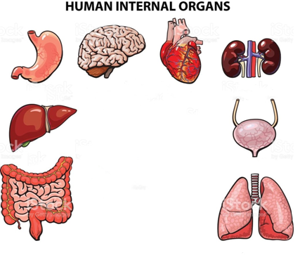

Body Systems: 1- , 2- , 3- , 4- , 5- , 6- , 7- , 8- , 9- .

